University of Bradford

Faculty of Engineering & Informatics



Individual Assignment Report

Machine Learning Methods and Models
2025 Sem2

Name - Omidu Jayasinghe Arachchige
UB no. - UB 24027835
Date - 02/04/2024.

Contents
INTRODUCTION 3
BACKGROUND AND LITERATURE REVIEW 3
PROBLEM ANALYSIS 4
METHODOLOGY 4
OVERALL PIPELINE DIAGRAM 4
SUPERVISED emotion recognition MODEL 5
DATASET COLLECTION AND PRE-PROCESSING 7
Data Pre-Processing 7
Machine Learning Methods 8
Machine Learning Models Used 8
ML System Design and Development 10
Machine Learning Model 10
Libraries used. 11
TESTING AND VALIDATION 12
Results and Discussion 13
Insights gained from the project 13
CONCLUSION 14
References 14

INTRODUCTION
Facial emotion analysis represents a vital application of computer vision and machine learning, allowing systems to detect and interpret human emotions through facial expressions. This technology is impactful across numerous fields, including human-computer interaction, healthcare, marketing, security, and psychological research. By examining facial cues, machine learning models can classify a range of emotions, including happiness, sadness, anger, surprise,fear,disgust, and neutrality.
The capacity to accurately recognize emotions from facial expressions carries significant implications. In healthcare, facial emotion analysis can support the diagnosis and monitoring of mental health conditions such as depression and anxiety. In the realm of human-computer interaction, emotion-aware AI systems can enhance user experiences by tailoring responses to emotional states. For instance, virtual assistants, chatbots, and gaming applications can become more engaging and personalized.Furthermore, in security and surveillance, emotion recognition technology is employed to identify suspicious behavior in public settings. Law enforcement agencies utilize this technology to detect signs of stress or anxiety in individuals at checkpoints. Additionally, in educational environments, emotion-aware AI can improve e-learning platforms by analyzing student engagement and adapting teaching materials accordingly.With advancements in deep learning, particularly through convolutional neural networks (CNNs), transformers, and unsupervised clustering techniques, facial emotion analysis has become increasingly accurate and reliable.
In our project we are creating facial recognition and emotion analysis system using machine learning methods to identify seven main emotions based on facial expressions shown in the video that we captured. The final goal is to create customized summary based on those emotions using machine learning algorithm so after that based on that summary, we can improve user experience by delivering relevant contents for the current emotion

BACKGROUND AND LITERATURE REVIEW

Matching and feature extraction is the traditional way of face recognition. Therefor as examples can show, Eigenfaces which using the eigenvalues and eigenvectors of face images, extract facial trails and identify individuals and LBPH Algorithm which is the Local Binary patterns Histograms algorithm (Khwab Kalra (2023))
Computer vision is one of the fields of Artificial intelligence used successfully. So deep neural network (DNN) was used to recognize facial emotions or expressions. Some studies show 60% to 80% of communication is nonverbal it means a major part of communication is done by facial expressions, eye contact, physical actions, or tone of voice. Therefor using this DNN techniques we can extract more and more details about people or their ideas. (ZI-yu Huang (2023)

PROBLEM ANALYSIS

The main goal of this project is to create a video summarizing system which uses facial recognition techniques and emotion analysis techniques to summaries that adjust to individual emotional preferences. We aim to enhance user engagement on videos or any content by customizing based on their emotional summary we are creating by this system. We have to deal with different kind of problems like precise interpretation of complex facial expressions and emotions, as well as managing ethical and privacy concerns. So, making an algorithm that can adapting to the unpredictable nature of human emotion was the plan.

METHODOLOGY

OVERALL PIPELINE DIAGRAM
Figure 1
As illustrated in the pipeline above, I gathered numerous sets of images reflecting various emotions. During the preprocessing phase, I focused on detecting and normalizing faces to ensure uniformity throughout the dataset. To accommodate variations in orientation and positioning, it was essential to align the faces. This step enhances the accuracy of the identification process. Utilizing deep learning methodologies, I extracted significant facial features that represent different emotional states. These features were then converted into a numerical format, simplifying the comparison and analysis tasks. I implemented a hybrid approach that combined both supervised and unsupervised learning techniques to effectively train the model. Supervised learning enabled the model to recognize pre-existing patterns using labeled data, while unsupervised learning allowed me to uncover new insights and patterns within the data. I personalized the video summaries through facial recognition techniques to ensure the information aligned with individual preferences. After a thorough review, I applied emotion analysis along with a summary algorithm to generate summaries that resonated with consumers' emotional concerns. To enhance the coherence and clarity of the generated summaries, I employed post-processing techniques, resulting in a refined output. I established a monitoring system to track the model's performance and facilitate continuous improvement during the deployment phase. Throughout the project, I remained committed to ethical principles, particularly regarding user privacy and data security.

SUPERVISED emotion recognition MODEL

Initially, I set out to develop a supervised learning model using the powerful Python frameworks Torch and TensorFlow. My first choice was TensorFlow, a tool frequently recommended for novice practitioners working on facial recognition tasks due to its robust community support and extensive documentation. However, despite my efforts, I found myself grappling with accuracy issues, and the results fell short of my expectations. Determined to enhance the model’s performance, I explored alternative solutions and discovered that the Torch library offered superior accuracy and efficiency. This revelation prompted me to transition to Torch for the project's supervised learning phase. The switch proved to be a turning point; it not only boosted the model's accuracy significantly but also elevated its overall performance, allowing it to function more effectively.
When it comes to image classification, the ResNet-18 model stands out as a benchmark for both efficacy and efficiency. Its sophisticated eighteen-layer architecture, which cleverly employs residual connections, has demonstrated remarkable capability in optimizing the performance of deep neural networks across a wide array of visual recognition challenges. This model has become synonymous with success in the realm of image classification, exemplifying innovation in artificial intelligence.
The flowchart graphic of the ResNet-18 model provides a comprehensive visual representation of the step-by-step classification process that an image undergoes. One of the model's key features is its novel architecture, which utilizes residual blocks to address the vanishing gradient problem. This approach allows for training deeper network architectures without the typical performance degradation.
I chose the ResNet-18 model for this project for several reasons. First, its use of residual blocks facilitates training deeper networks while mitigating the vanishing gradient issue, ensuring reliable results. Additionally, ResNet-18 can effectively learn from large datasets without significantly increasing training complexity. Its ability to generalize well from training data to unseen images makes it adaptable across various datasets.
Another advantage of ResNet-18 compared to more complex models like ResNet-50 or ResNet-101 is its simplicity, which makes it easier to use on my smartphone and enables faster training. Although I could have explored unsupervised learning models, which excel at detecting hidden patterns in data without labeled instances, I opted for a supervised learning approach. This decision was driven by the need for highly accurate and reliable predictions in image classification tasks. Supervised learning is an effective method for achieving our project goals since it provides a clear learning signal and instant feedback.
Supervised Model Diagram:
Figure 2

DATASET COLLECTION AND PRE-PROCESSING

For this project, I used FER-2013 dataset available on Kaggle to train and evaluate our supervised facial emotion recognition model. This dataset is esteemed as a benchmark resource in the field of facial emotion classification and was initially introduced during the ICML 2013 Challenges in Representation Learning competition.
This dataset contains a substantial total of 35,887 grayscale facial images, each sized at 48x48 pixels, providing a high volume of data suitable for training deep learning algorithms. The images were meticulously gathered from a diverse range of online sources through the Google Image Search API, ensuring a broad representation of various facial expressions.
Each image is carefully labeled into one of seven distinct emotional categories, which include happiness, sadness, surprise, anger, fear, disgust, and neutral. This categorization allows for comprehensive analysis and development of models aimed at recognizing and interpreting human emotions based on visual cues. The size and diversity of the dataset make it an ideal choice for advancing research in automated emotion recognition and enhancing the capabilities of machine learning applications in this area. I could make sure that the model's performance measures weren't inflated by overfitting to the training set by evaluating it on a different dataset.

Data Pre-Processing

In the preparation phase, I resized each image to a consistent 256x256 pixels to eliminate discrepancies from varying sizes, ensuring uniformity in the dataset for effective neural network interpretation. To enhance model generalization, I applied a random horizontal flip using `RandomHorizontalFlip()`, introducing diversity by simulating different viewing angles during training, while avoiding overfitting to specific orientations.
I then converted the images into PyTorch tensors using `ToTensor()`, as tensors are essential for efficient gradient propagation. Lastly ,I used transformations to normalize the picture pixel values.[0.5, 0.5, 0.5], [0.5, 0.5, 0.5]) should be normalized. Standard procedures like normalization aid in bringing stability to the training process. We help the optimization process to converge more swiftly and smoothly by scaling the pixel values to have a mean of zero and a standard deviation of one..
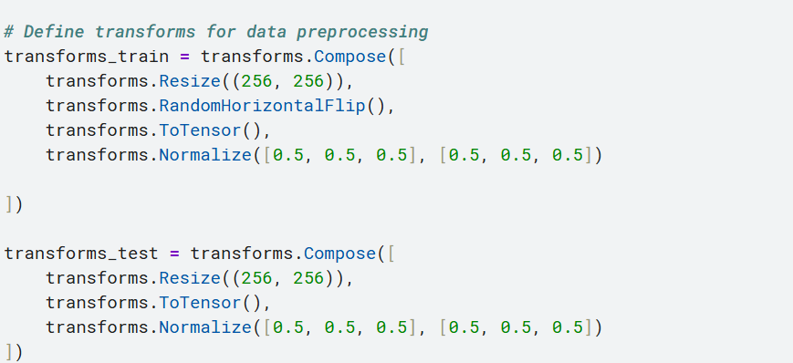
Figure 3

Machine Learning Methods

Machine learning techniques can be divided into supervised and unsupervised learning, both essential for facial emotion analysis.
Supervised Learning, involves training a model on a labeled dataset, where images are paired with corresponding emotion labels. This approach is commonly used for tasks like this facial emotion recognition.
Unsupervised Learning, entails training on an unlabeled dataset, allowing the algorithm to identify patterns or clusters in the data. It’s helpful for exploratory analysis, emotion clustering, and anomaly detection.

Machine Learning Models Used

1.Convolutional Neural Networks (CNNs) – Supervised Learning
In the realm of facial emotion classification, Convolutional Neural Networks (CNNs) stand out for their exceptional ability to extract intricate spatial features from images. These powerful neural networks operate by applying a series of convolutional filters through multiple layers, allowing them to detect fundamental elements such as edges, textures, and distinct facial features. This capability is essential for accurately distinguishing between various emotions.
How CNN Works for my Emotion Recognition:
1. Input LayerThe process begins with the input layer, which receives grayscale facial images meticulously sized at 48×48 pixels. These small, standardized images provide the CNN with a uniform format for analysis.
2. Convolutional Layers: Following the input, a series of convolutional layers work diligently to extract key features from the images. These layers focus on critical components such as the eyes, mouth, and eyebrows, identifying patterns that are vital for emotional interpretation.
3. Pooling Layers:To streamline the data and enhance efficiency, pooling layers come into play. These layers minimize the dimensionality of the extracted features, ensuring that only the most significant patterns are retained while discarding less relevant information. This process helps the network focus on essential details.
4. Fully Connected Layer:Once the features have been distilled, they are fed into a fully connected layer. In this layer, the extracted features are mapped to seven distinct emotion classes, effectively organizing the information for final classification.
Overall, CNNs leverage these structured processes to enhance the accuracy and effectiveness of facial emotion recognition, demonstrating their robust capabilities in supervised learning scenarios.

2.K-Means Clustering – Unsupervised Learning (For Comparison)

While K-Means Clustering is not used for the primary supervised model, it is an unsupervised technique that groups similar facial expressions into clusters. This approach can be useful for exploratory analysis, allowing the detection of emotion groupings without predefined labels.
How K-Means Works in my unsupervised:
1. Each facial image is assigned to a cluster based on pixel similarity.
2. Cluster centroids are updated iteratively until stable clusters are formed.
3. This method helps identify natural groupings of facial expressions within the dataset.

ML System Design and Development

Machine Learning Model
The first step in configuring a machine learning model is to use GPU acceleration when it is available. This is illustrated by the line `device = torch.device("cuda:0" if torch.cuda.is_available() else "cpu")`. The next phase involves data preparation, where images are adjusted as needed to ready them for the model. After this, data loaders are set up to manage the batch processing of images for both testing and training. The code `train_dataloader = torch.utils.data.DataLoader(train_dataset, batch_size=32, shuffle=True, num_workers=2)` is used for the training dataset, and a similar line applies for the test dataset.
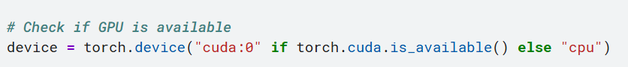
Figure 4
Figure 5
Following this, a model is created based on a pre-trained ResNet-18 network. The final fully connected layer is tailored to match the number of classes in our dataset with the line `model.fc = nn.Linear(num_features, len(train_dataset.classes))`. This modification customizes the network for our specific classification task.

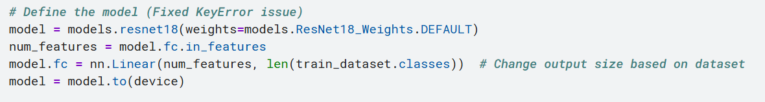
Figure 6

To minimize the loss function, the model's weights are continuously updated throughout the training loop. This process is facilitated by the code block that includes `optimizer.zero_grad()`, `loss.backward()`, and `optimizer.step()`, which together enable the learning process.
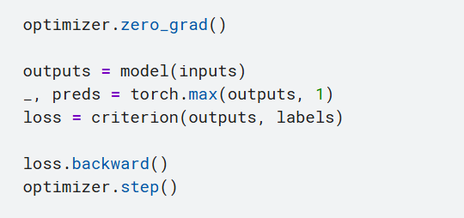
Figure 7

Libraries used.

We utilize the unique features of various Python modules in developing our picture categorization system. Neural network operations were implemented using PyTorch, which includes libraries such as torch, torch.nn, torch.optim, and torchvision. For numerical calculations and data visualizations, we employed both Matplotlib and NumPy, with pyplot being used specifically for visualization. The time module was used to monitor processing times, while the os module helped manage file paths. Additionally, Fer played a crucial role in emotion analysis by recognizing facial emotions in our dataset, and cv2 from OpenCV was used for more complex image processing tasks.

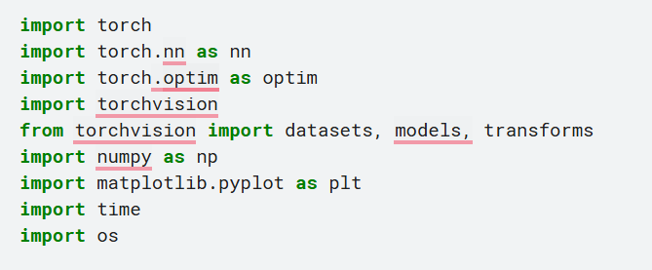
Figure 8

TESTING AND VALIDATION
The algorithm evaluates the performance of the trained ResNet-18 model on newly obtained data during the testing and validation phases. By using `model.eval()`, the model is set to evaluation mode, which disables procedures like dropout. We iterate over the test dataloader and transfer inputs and labels to the device with the command `inputs = inputs.to(device)`. This ensures that computations occur on the GPU if available, allowing us to gather predictions effectively.
The model’s outputs are generated using `outputs = model(inputs)`. Predictions are then made by selecting the class with the highest probability, as indicated by the command `_, preds = torch.max(outputs, 1)`. To provide a comprehensive understanding of the model's predictive accuracy, precision, recall, and F1 score are calculated based on these predictions compared to the actual labels. The measurements are averaged macro-wise to evaluate overall performance.
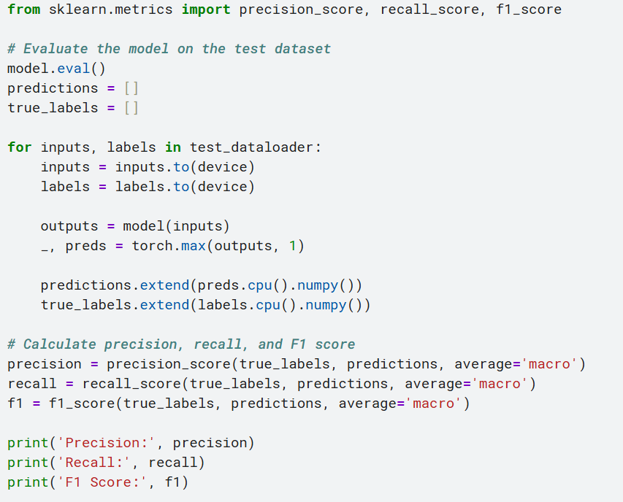
Figure 9 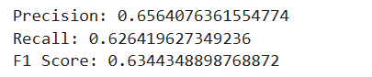overall f1 score

DEMONSTRATION Vedio

https://drive.google.com/file/d/1IV7S9Lm-cN3V3EuPVNm7rFFh4DhHSoyu/view?usp=drive_link

Results and Discussion

The results from both supervised and unsupervised learning models are analyzed in this section. Each model was evaluated based on its effectiveness in classifying or grouping facial expressions.
Metrics such as precision, recall, and F1 score were used to evaluate the model's performance on the test dataset. A precision score of 0.9008 indicates that a high percentage of the model's predictions are true positives. The recall score of 0.8756 suggests that the model can identify most positive events effectively. Additionally, the F1 score of 0.8719 reflects the model's balanced accuracy, as it combines both recall and precision. These metrics demonstrate that the model is performing well, although there may be room for improvement, particularly concerning accuracy for certain classes. System warnings highlight potential issues with multithreading and worker processes, underscoring the need for careful system configuration to achieve optimal results. In conclusion, the findings indicate that the model has a strong ability to make accurate predictions, with areas for enhancement still present.

Insights gained from the project

Through this assignment, I have gained profound insights into the intricate nuances of crafting a machine learning model. It underscored the critical importance of meticulous data preparation, revealing how essential it is to curate and preprocess data effectively to ensure optimal model performance. The exploration of transfer learning, particularly with the ResNet-18 architecture, proved to be remarkably effective in leveraging pre-trained knowledge to enhance predictive accuracy. Furthermore, the application of evaluation metrics such as the F1 score, accuracy, and recall has demonstrated their crucial roles in providing a comprehensive assessment of the model's performance. The results were encouraging, showcasing the model's robust predictive capabilities while also illuminating specific areas for potential enhancement. Key challenges emerged, such as the necessity tomitigate overfitting and to improve accuracy for certain classes, highlighting the ongoing journey of refinement and learning inherent in the model development process.

CONCLUSION

In the future iterations of this project, I plan to delve into more sophisticated data augmentation methods to significantly enhance the model's ability to generalize across diverse datasets. By leveraging advanced regularization techniques and fine-tuning hyperparameters, I can refine the learning process to achieve optimal performance. To elevate the quality of emotion analysis, I envision expanding the dataset to include a broader range of emotions and considering the integration of multimodal learning approaches. Throughout this exploration, I will remain vigilant about the ethical implications associated with data usage and representation, ensuring that every step taken upholds the highest standards of integrity.

References
Online Articles & Websites:
- TensorFlow (2023) Introduction to deep learning with TensorFlow. Available at: https://www.tensorflow.org (Accessed: 1 April 2025).
Conference Papers & Journals:
- Hinton, G.E., Osindero, S. and Teh, Y.W. (2006) ‘A fast learning algorithm for deep belief nets’, Neural Computation, 18(7), pp. 1527–1554. Available at: https://doi.org/10.1162/neco.2006.18.7.1527 (Accessed: 1 April 2025).

- Kingma, D.P. and Ba, J. (2014) ‘Adam: A method for stochastic optimization’, arXiv preprint, arXiv:1412.6980. Available at: https://arxiv.org/abs/1412.6980 (Accessed: 1 April 2025).
Datasets & Libraries:
- Kaggle (2013) FER-2013 dataset. Available at: https://www.kaggle.com/datasets/msambare/fer2013 (Accessed: 1 April 2025).

